Homework for week 2, submission deadline 23:59 on Sunday night.
- Choose your own topics from following list or your own.
- Gut microbiota and metabolic disease
- Single-cell transcriptomics in cancer immunology
- Antibiotic resistance genomics
- Epigenetic regulation in neurological disorders
- Muscle regeneration and aging
- Proteomic biomarkers in MAFLD/MASH
Finish the following question section we covered in the class
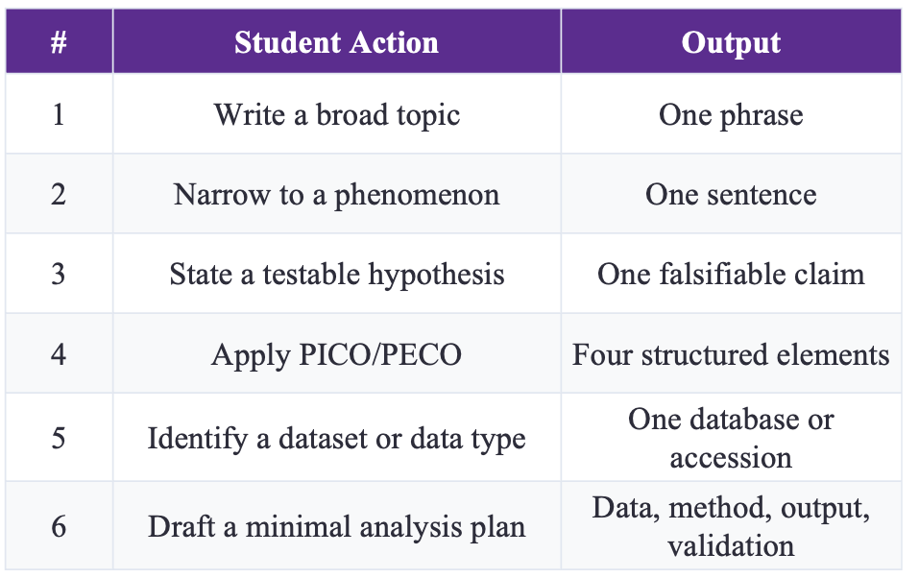
Broad topic：Microalgae-based wastewater treatment.
Phenomenon：A. platensis may grow poorly in diluted dairy farm wastewater when bicarbonate availability and/or alkalinity is inadequate.
Research question：Are insufficient bicarbonate availability and/or alkalinity more strongly associated with the poor growth of A. platensis in diluted dairy farm wastewater than insufficient CO₂ supply alone?
Testable hypothesis：The poor growth of A. platensis in dairy farm wastewater is associated with insufficient bicarbonate availability and/or alkalinity rather than simply insufficient CO₂ supply.
PICO：
P）: A. platensis cultivated in diluted dairy farm wastewater.
I）: a 2×2 factorial manipulation of NaHCO₃ supplementation and CO₂ supplementation, producing untreated, NaHCO₃-only, CO₂-only, and combined-treatment groups.
C）: the untreated group and the direct comparison between the NaHCO₃-only and CO₂-only groups.
O）: specific growth rate and volumetric biomass productivity; pH, total alkalinity, dissolved inorganic carbon, and, where feasible, estimated HCO₃⁻/CO₂ composition as supporting measurements.
Dataset/data type：Primary experimental data: repeated measurements of optical density or dry biomass, pH, total alkalinity, dissolved inorganic carbon, treatment-specific CO₂ input, and, where feasible, estimated HCO₃⁻/CO₂ composition.
Minimal analysis plan：Use at least three independent culture replicates per treatment. Keep inoculum, wastewater dilution, light, temperature, culture volume, baseline aeration, and culture duration constant, and record the CO₂ dose. Plot growth curves, calculate specific growth rate and volumetric biomass productivity, and use two-way ANOVA to test the main effects of NaHCO₃ and CO₂ and their interaction. Use correlation or regression analyses to compare growth with alkalinity, bicarbonate-related measurements, and CO₂ supply.

NaHCO₃ changes inorganic carbon, pH, alkalinity, and sodium concentration at the same time. Therefore, this experiment can support or fail to support the association stated in the hypothesis, but it cannot establish a unique causal mechanism by itself. If CO₂ supplementation alone improves growth as much as NaHCO₃ supplementation, the claim that the problem is not simply insufficient CO₂ supply would not be supported. A higher NaHCO₃ level could also inhibit growth through excessive alkalinity, sodium concentration, or osmotic stress.

- Find and read two research papers in the folder and answer following question based on these two papers.
  - Question 1: Use the PICO/PECO, what are they for these two papers?
  - Question 2: What kind of dataset or data type these two papers use?
  - Question 3: What is the hypothesis of these two research?
Paper 1: Priya et al. (2022)
a). PICO/PECO:
Population: Individuals from colorectal cancer (CRC), inflammatory bowel disease (IBD), and irritable bowel syndrome (IBS) cohorts, with paired colonic mucosal host transcriptomic and microbiome data.
Exposure: Disease status (CRC, IBD, or IBS).
Comparator: Corresponding non-disease or control samples within each disease cohort.
Outcome: Shared and disease-specific associations between gut microbial taxa and host gene expression/pathways.
PECO is more appropriate than PICO because disease status was observed rather than experimentally assigned.
b). Dataset/data type:Paired host transcriptomic (RNA-seq) and gut microbiome (16S rRNA sequencing) data from colonic mucosal samples across CRC, IBD, and IBS cohorts. The study included 208 paired host transcriptomic and microbiome samples: 88 pairs in the CRC cohort (44 tumor and 44 patient-matched normal samples), 78 pairs in the IBD cohort (56 patients and 22 controls), and 42 pairs in the IBS cohort (29 patients and 13 controls).
c). Hypothesis:Explicit hypothesis: Host genes and gut microbial taxa involved in common biological functions act in a coordinated manner and therefore show correlated gene-expression and microbial-abundance patterns. The study further investigates whether these host gene–microbiome associations are shared across CRC, IBD, and IBS or are disease-specific.

Paper 2: Huang et al. (2023)
a). PICO/PECO:
Population: Infants during the first months of life.
Exposure: Development of infantile eczema by 6 months of age.
Comparator: Infants without eczema.
Outcome: Differences in early gut microbial colonization, microbial diversity, composition, and microbial network structure during the first 100 days of life.
PECO is more appropriate than PICO because eczema status was observed rather than experimentally assigned.
Dataset/data type:Longitudinal 16S rRNA gene amplicon sequencing data from infant fecal samples collected at birth and at 1, 2, and 3 months of age. The main analysis included 34 infants (22 controls and 12 infants with eczema). Independent longitudinal datasets from Swedish and Danish cohorts were additionally used to examine microbial-network patterns in healthy infants.
Hypothesis:Infants who develop eczema have different early-life gut microbial succession and microbial-network dynamics compared with healthy infants. In particular, healthy infants are expected to show a more regular increase in microbial-network complexity during early development, whereas this pattern may be disrupted in infants who develop eczema.

- Based on your research interest, refine the search in PUBMED, and sort, identify the latest and the most important studies in your field. Read this paper and answer three questions:
  - Question 1: Use the PICO/PECO, what are they for these two papers?
  - Question 2: What kind of dataset or data type these two papers use?
  - Question 3: What is the hypothesis of these two research?

Paper 1: Liang et al. (2023)
Title: Cultivation of Spirulina platensis for nutrient removal from piggery wastewater

a). PICO
Population:Spirulina platensis cultivated in diluted piggery wastewater.
Intervention:Supplementation with different concentrations of sodium bicarbonate, together with optimization of culture conditions including pH, light intensity, and photoperiod.
Comparator:Diluted piggery wastewater without sodium bicarbonate supplementation, and comparisons among different NaHCO₃ concentrations and culture conditions.
Outcome:Growth of S. platensis measured mainly by OD560 and biomass concentration; nutrient and pollutant removal including TN, TP, COD, Cu and Zn; and biomass biochemical composition.

b). Dataset/data type:Primary experimental time-series and endpoint data, including OD560/biomass growth, wastewater nutrient and heavy-metal concentrations, culture-condition variables, nutrient-removal efficiencies, and biochemical composition of the harvested Spirulina biomass.

c). Hypothesis： Diluted piggery wastewater contains sufficient nitrogen, phosphorus and other nutrients to support S. platensis, but bicarbonate availability is limiting; therefore, sodium bicarbonate supplementation should improve Spirulina growth and enable effective nutrient removal from the wastewater.

Paper 2: Yu et al. (2025)
Title: Maximizing CO₂ biofixation of Arthrospira platensis using an in situ bicarbonate pool: Optimization of CO₂-regulated pH and bicarbonate concentration

a). PICO
Population:Arthrospira platensis cultured in modified Zarrouk medium in laboratory and outdoor photobioreactor/raceway systems.
Intervention:Manipulation of bicarbonate-pool concentration using different NaHCO₃ levels, together with CO₂-regulated pH.
Comparator:Cultures with different NaHCO₃ concentrations and different CO₂-regulated pH values, including a 0 g/L NaHCO₃ condition.
Outcome:Biomass production/productivity, CO₂ fixation rate, exogenous CO₂ utilization efficiency, photosynthetic performance, and production of high-value biomass components such as phycocyanin and carotenoids.

b). Dataset / data type：Primary experimental data from laboratory and scale-up cultivation, including biomass dry weight and productivity, bicarbonate concentration, CO₂-regulated pH, CO₂ fixation and utilization efficiency, photosynthetic parameters, and biochemical composition of A. platensis biomass.

c). Hypothesis：Inferred hypothesis: Maintaining an appropriate bicarbonate pool together with CO₂-regulated pH will increase inorganic-carbon availability for A. platensis, thereby improving biomass production, CO₂ fixation and exogenous CO₂ utilization efficiency compared with conditions lacking an adequate bicarbonate pool.

